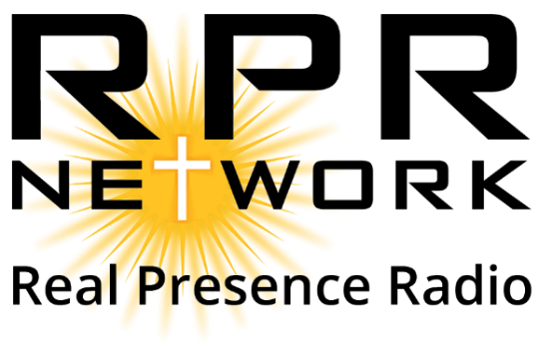
Spring Live Drive 2024
Tuesday, May 14
Time | On-Air |  | Location
7:00-9:00 AM | Hosts: Steve Splonskowski & Brad Gray | Guests: Sunshine Diem, Chuck Huber | Link
9:00-11:00 AM | Hosts: Lynne Devitt & Fr. Bryce Lundgren | Guests: Zeke Zebrowski, John & Julie Chick, Ruth Peyrot | Link
11:00 AM – 1:00 PM | Hosts: Nathan Sather & John Clark | Guests: Bryan Wilburn, Fr. Luke Meyer, Casey & Jennie Davis | Link
1:00-3:00 PM | Hosts: Karen Selensky & Father Greg Luger | Guests: Laura Mibek, Brian & Kristie Michels, Paul & Nadia Smetana | Link
3:00-5:00 PM | Hosts: Heather Karrow & Doug Weingardt | Guests: Michael Pauley & Marcus Ashlock | Link
5:00-7:00 PM | Hosts: Father Andrzej & Lynne Devitt | Guests: Deacon Phil Thompson, Justin Carlin & Dr. Chad Carpenter | Link
Wednesday, May 15
Time | On-Air |  | Location
7:00-9:00 AM | Hosts: Brandon Clark & Sunshine Diem | Guest: Monsignor Schlesselmann, Benton Schmidt, Nate & RyAnne Carr | Link
9:00-11:00 AM | Hosts: Karen Selensky, Father Russ Kovash, Father Justin Johns | Guests: Mike Luger, Virginia Dolajak & Alice Berning | Link
11:00 AM – 1:00 PM | Hosts: Father Richard Kunst & Cindy Jennings | Guests: Father Anthony Craig, Monica Hendrickson & Loran Wappes | Link
1:00-3:00 PM | Hosts: Mike Kiedrowski & Tony Krebs | Guests: Father Shane Campbell, Chuck & Annette Steffan, Deacon Loren & Wendy Kordonwoy | Link
3:00-5:00 PM | Hosts: Brandon Clark & Father Chad Wilhelm | Guests: Jeff Grumbauer, Deacon Ken Votava, Deacon Tom Geffre, Whitney & Rory Samsen | Link
5:00-7:00 PM | Hosts: Heather Karrow & Doug Weingardt | Guests: Becky McQuistan, Ryan & Beth Noonan, Scott Jucht | Link
Thursday, May 16
Time | On-Air |  | Location
7:00-9:00 AM | Hosts: Melissa Scaccioi & Lynne Devitt | Guests: Jason Adkins, Peter & Theresa Martin | Link
9:00-11:00 AM | Hosts: Father Jason Gross & Stacey Hanson | Guests: Margaret & Dan Hoeger, Sal DeLio, Brent Mikkelson | Link
11:00 AM – 1:00 PM | Hosts: Heather Karrow & Doug Weingardt | Guests: Morgan Stadler, Elissa Allen & Lee Zacher | Link
1:00-3:00 PM | Hosts: Wayne Sanders & Sunshine Diem | Guests: Pam Clemens, John & Trasa Diem & Dustin Moore | Link
3:00-5:00 PM | Hosts: Karen Selensky & Father Gary Benz | Guests: David & Robin Johnson, Deacon Lance & Anissa Gartner & Walter Emter | Link
5:00-7:00 PM | Hosts: Jack & Doreen Kennelly | Guests: Pete & Tammy Shaw, Steve Loegering & Lynne Devitt | Link

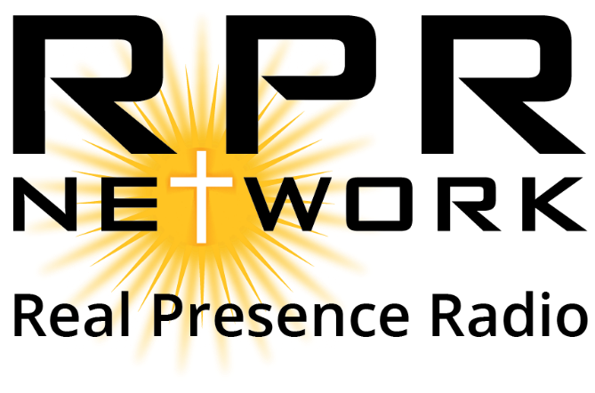

Fall Live Drive 2024
Wednesday, Sept 11
Time | On-Air |  | Location
7:00-9:00 AM | Hosts: Lynne Devitt & Tim Mosser | Guests: Steve Splonskowski, Keith Braddock, and Micah Gallagher | Link
9:00-11:00 AM | Hosts: Doug Weingardt & Eric Gallagher | Guests: Noah & Katie McCrary | Link
11:00 AM – 1:00 PM | Hosts: Sunshine Diem & Dcn. Rob Thom | Guest: Bob Roers, Mike Prewedo and Fr. Chuck Huck | Link
1:00-3:00 PM | Hosts: Karen Selensky & Jim Bitz | Guest: Stephen & Lori Gross, Tom & Tori Gross, Tyler Moos | Link
3:00-5:00 PM | Hosts: Lynne Devitt and Peggy Ricci | Guests: Bishop Powers, David Dusek, & Joy Pyle | Link
5:00-7:00 PM | Hosts: Heather Karrow & Amy Julian | Guests: Tami Whalen, Mike Ochoa, & Kyle Benjamin | Link
Thursday, Sept 12
Time | On-Air |  | Location
7:00-9:00 AM | Hosts: Sunshine Diem & Kevin Fischer | Guests: Veronica Pavek, Aaron and Shanna Filzen, & Bishop John Folda | Link
9:00-11:00 AM | Hosts: Karen Selensky & Fr. Fred Harveyr | Guests: Deacon James Belohlavek, Jan Frohlich, & Rose Krukenberg | Link
11:00 AM – 1:00 PM | Hosts: Fr. Richard Kunst and Cindy Jennings | Guests: Marty LaPlante & Rosemary Tarnowski | Link
1:00–3:00 PM | Hosts: Doug Weingardt and Heather Karrow | Guests: Larry Tentinger & Julie Dickes | Link
3:00-5:00 PM | Hosts: Sunshine Diem & Brandon Clark | Guests: Hope Bach & Brian LaPlante | Link
5:00-7:00 PM | Hosts: Camille & Michael Pauley | Guests: JD and Jennifer Henderson | Link
Friday, Sept 13
Time | On-Air |  | Location
7:00-9:00 AM | Hosts: Melissa Scaccio & Margaret Ricci | Guests: Fr. Randal Kasel, John and Debbie O'Meara | Link
9:00-11:00 AM | Hosts: Sunshine Diem and Wayne Sanders | Guests: John Grommesh, Paulette Schmitt, & Fr. Jamer Ermer | Link
11:00 AM – 1:00 PM | Hosts: Heather Karrow and Doug Weingardt | Guests: Fr. Mark Lichter & Rachel Mueller | Link
1;00-3:00 PM | Hosts: Brandon & Tonia Clark | Guests: Bob Noel, Veronica Pavek, & Cy Kellet | Link
3:00-5:00 PM | Hosts: Karen Selesnky and Fr. Brandon Wolf | Guests: Deacon Ron Keller, Chuck and Reba Olsen, & Liane Filkowski | Link
5:00-7:00 PM | Hosts: Lynne Devitt & Jerry Meier | Guests: Sharon Meier, Roxane Salonen, & Jack and Doreen Kennelly | Link

